Notarized Affidavit of Religious Belief for Exemption from COVID Vaccination

- I, ________________________, am a practicing Catholic, and my belief is sincere and meaningful.
- The Catholic church has, over the centuries, extensively addressed issues related to bodily integrity generally and vaccination specifically, including issues of voluntariness and vaccine mandates.
- Regarding COVID in particular, the Congregation for the Doctrine of the Faith (CDF) published a “Note on the morality of using some anti-Covid-19 vaccines” on December 21, 2020, stating that:
  - COVID-19 vaccines that used cell lines originating from aborted fetuses are morally compromised. [Note: The J&J vaccine “is an adenoviral vector grown in the PER.C6 cell line that originated from a healthy 18-week-old aborted child.” The Pfizer and Moderna vaccines were tested using the “morally compromised HEK-293 cell line,” originating from “a child aborted in the Netherlands in 1972.”] Catholics have a moral duty to avoid use of such vaccines.
  - However, this moral duty “is not obligatory if there is a grave danger, such as the otherwise uncontainable spread” of COVID-19.
  - “In the absence of other means to stop or even prevent the epidemic, the common good may recommend vaccination.”
  - “In such a case, all vaccinations recognized as clinically safe and effective can be used in good conscience.”
  - “At the same time, practical reason makes evident that vaccination is not, as a rule, a moral obligation and that, therefore, it must be voluntary.”
  - “Those who, […] for reasons of conscience, refuse vaccines produced with cell lines from aborted fetuses, must do their utmost to avoid, by other prophylactic means and appropriate behavior, becoming vehicles for the transmission of the infectious agent.”
- To summarize, the moral duty to avoid use of these three COVID vaccines is not obligatory only if:
  - The spread of COVID-19 is otherwise uncontainable,
  - There is an absence of other means by which to stop or prevent the epidemic,
  - The vaccines are clinically safe, and
  - The choice to receive a vaccine must be voluntary.
- If any element is not satisfied, the moral duty to avoid using the vaccines is obligatory. In which case, _____________________’s vaccine mandate violates my Catholic faith.
- Even if all elements were satisfied, a non-obligatory moral duty does not equate to me taking a vaccine, much less authorizing a vaccine mandate. It merely means that, as a Catholic, I have the option to evaluate the evidence myself and make my own prudential decision whether to receive a vaccine; to repeat, “it must be voluntary.” I can choose to not take a vaccine, in which case I must “avoid, by other prophylactic means and appropriate behavior, becoming [a] vehicle for the transmission of the infectious agent.”
- Here, all four elements have yet to be satisfied.
- The threshold issue is voluntariness: “vaccination is not, as a rule, a moral obligation and […], therefore, it must be voluntary.” This mandate violates my Catholic faith because it is, by definition, not voluntary.
- Rather than a coercive mandate, ____________________ should emphasize the virtue of Prudence, allowing each student/employee to make a prudential decision whether to take a COVID vaccine. Failing this, _____________ should follow the science by changing the mandate to acknowledge two additional “means by which to stop or prevent the epidemic,” two additional forms of protection that are equivalent to or greater than protection gained via some or all of the three COVID vaccines:
  - Naturally acquired immunity via prior COVID infection and subsequent recovery; and
  - Prophylactic ivermectin, taken weekly in accordance with the FLCCC Alliance protocol.
- Consistent with the CDF note, I am already taking the most effective “other prophylactic means” as an alternative to vaccination: ivermectin taken weekly as a prophylactic, per the FLCCC Alliance protocol. Regarding ivermectin’s efficacy against COVID, as both prophylaxis and treatment, please see the attached 4-page summary. The full 47-page meta-analysis is at https://ivmmeta.com/ .
- If _____________________ decides to acknowledge the ivermectin evidence and allow this form of protection as an alternative to vaccination, I am willing to sign something weekly verifying that I am taking the medication.
- Furthermore, there is evidence that the three COVID vaccines are not clinically safe. The AMERICA’S FRONTLINE DOCTORS, et al. v. XAVIER BECERRA, Secretary of the U.S. Department of Health and Human Services, et al. complaint mentions some of this evidence, including myocarditis and pericarditis in young men, per the CDC.
- The most concerning piece of evidence is a graph created using data from Pfizer (next page). As background:
  - All three vaccines utilize the Spike protein. Recent studies, indicate the Spike protein alone (without coronavirus infection per se) is enough to cause damage, inducing symptoms similar to catching COVID-19. This fact appears to have come as a surprise to the vaccine developers.
  - The three vaccines were designed to anchor the Spike protein to the cell; the Spike protein was not supposed to flow freely in the blood. After injection, the Spike protein was supposed to initially stay in and around the injection site, then eventually end up in the liver to “get chewed up by various destructive enzymes.”
- However, the Pfizer data (chart on next page) show something different happening in reality:
  - During the initial 8 hours after injection, the Spike protein is flowing freely in both the blood plasma and whole blood. This indicates that the “anchoring” did not work. This was not supposed to happen.
  - The Spike protein is then concentrating in both the ovaries and bone marrow. This was not supposed to happen either. The Spike protein was supposed to end up in the liver to “get chewed up by various destructive enzymes.”
- Thus far, there is only one year of data available on these three vaccines; nobody knows what the long-term effects will be. This makes Point 14(b) particularly concerning. Concentration of the Spike protein in the ovaries suggests infertility or birth defects as long-term effects, and concentration in the bone marrow suggests leukemia or autoimmune disorders.
- As a Catholic, I support life. This position is not limited to opposing abortion; it extends to opposing both COVID vaccines tested using aborted fetal cell lines and a vaccine mandate that may, based on available evidence, cause infertility in females and/or birth defects in future children.
- _______________________’s vaccine mandate applies to both males and females. As a Catholic, I believe that any risk of infertility - for anyone - is an unacceptably high risk. Forcing female students/employees to take this risk by mandating vaccination when the safer alternative of prophylactic ivermectin is available and known is unethical, inhumane, illegal, and in violation of my Catholic faith. ___________________ should eliminate its vaccine mandate, but failing that, female students/employees should be exempted from the mandate.

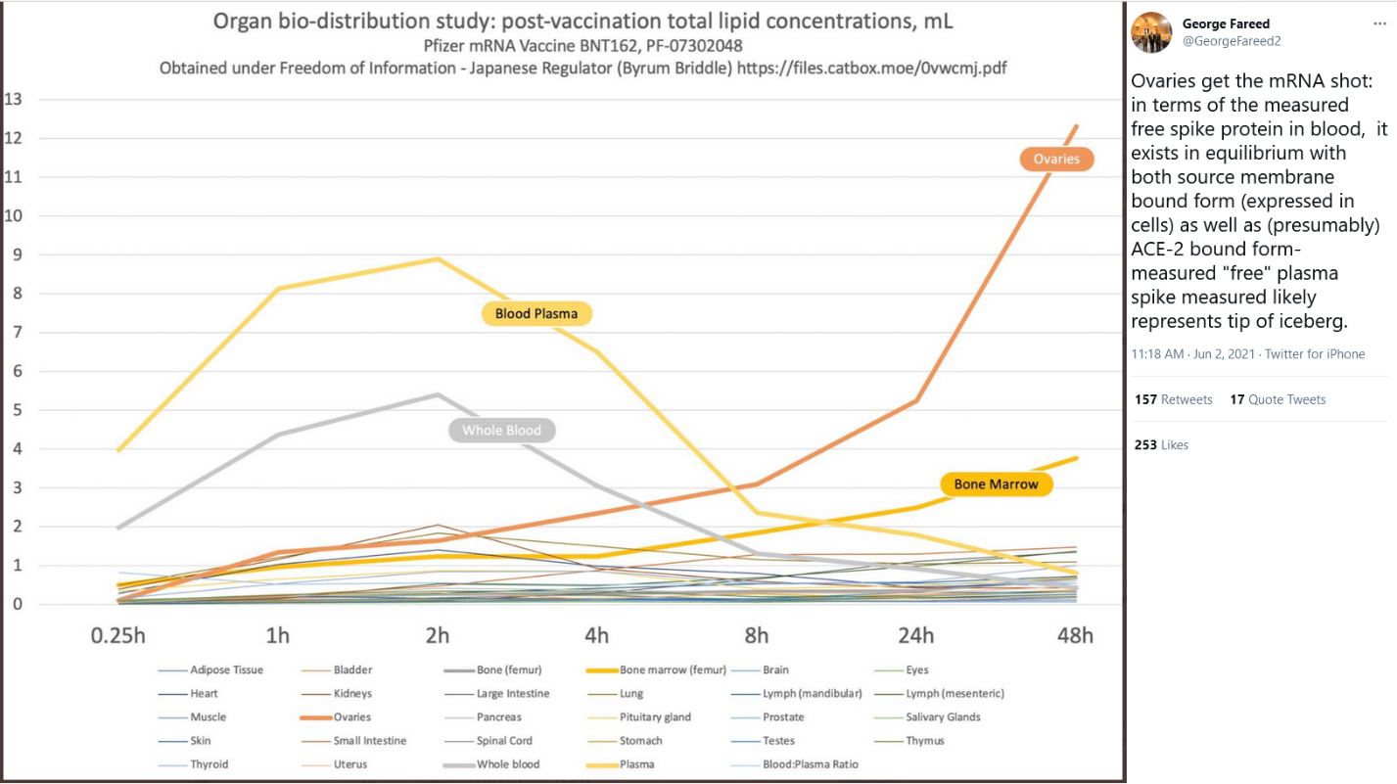

I declare under penalty of perjury that the foregoing is true and correct. Executed on __________, 2021.

_____________ ____________
Name Date

State of __________________: ss

I hereby certify that on this ________ day of _________, 2021, before me, the subscriber, a notary public in and for the aforesaid jurisdiction, personally appeared ________________________, known to me, and executed the foregoing affidavit, and made oath in due form of law, under the penalties of perjury, that the affidavit is his/her act and deed, that the matters and facts herein contained are true to the best of his/her knowledge.

____________
Notary Public
My Commission expires: ____________

https://www.vatican.va/roman_curia/congregations/cfaith/documents/rc_con_cfaith_doc_20201221_nota-vaccini-anticovid_en.html
https://www.catholicworldreport.com/2021/03/03/opinion-its-time-to-get-beyond-vaccines/
https://www.usccb.org/moral-considerations-covid-vaccines
https://covid19criticalcare.com/covid-19-protocols/
https://www.cdc.gov/coronavirus/2019-ncov/vaccines/safety/myocarditis.html
https://www.ahajournals.org/doi/full/10.1161/CIRCRESAHA.121.318902
https://www.contagionlive.com/view/spike-protein-of-sars-cov-2-virus-alone-can-cause-damage-to-lungs
https://podcasts.apple.com/us/podcast/how-to-save-the-world-in-three-easy-steps/id1471581521?i=1000525032595
https://blogs.sciencemag.org/pipeline/archives/2021/05/04/spike-protein-behavior

